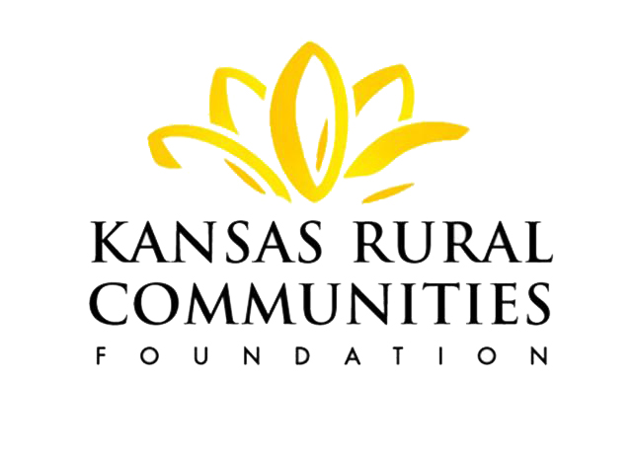
Kansas Rural Communities Foundation
FUND AGREEMENT

THIS AGREEMENT is made and entered into on this day of _________________, 20 __, between ________________ ________________________________ (Donor) and The Kansas Rural Communities Foundation (Foundation), a not-for-profit Kansas corporation exempt from income taxation pursuant to Section 501(c)(3) of the Internal Revenue Code.

IT IS AGREED:

TRANSFER. The Donor hereby gives, assigns, transfers, and delivers to the Foundation the sum of ______________________ Dollars ($__________________). This property and all future gifts and other additions (the Property) shall be held, administered, and distributed in accordance with this Agreement.

SEGREGATION OF FUND. The Property shall be held by the Foundation under the name of “___________________________ _______________________” (the Fund). The income and principal of the Fund may be either comingled with other Foundation assets or held in a separate account.

PURPOSE OF THE FUND. The Fund is established to/for: “

.”

ESTIMATED DURATON OF FUND ________________________________________

CONTRIBUTIONS. The Fund may receive and accept assets from the Donor or from any person, corporation, institution, estate, trust or other entity who or which desires to contribute thereto and have such assets administered and distributed in accordance with the provisions hereof. Said intent shall be presumed conclusively from the receipt of any assets, security or check designated for the Fund or received in such a way that the Foundation believes it is the intent of the donor to have such assets added to the Fund.
DISTRIBUTION OF FUNDS. The income and principal from the Fund shall be granted or expended for or in furtherance of the purpose of the Fund. Distributions from the fund shall be requested by the Board of Trustees of the Donor and/or its Fund Advisory Committee in furtherance of the charitable purposes of the fund and in accordance with all applicable laws. The Governing Board of the Kansas Rural Communities Foundation shall review each such request as necessary. Such requests shall not be unreasonably refused.
VARIANCE POWER. The IRS regulations require that the community foundation’s governing body have the power: “To modify any restriction or condition on the distribution of funds for any specified charitable purposes or to specified organizations if in the sole judgment of the governing body (without the necessity of the approval of any participating trustee, custodian, or agent), such restriction or condition becomes, in effect, unnecessary, incapable of fulfillment, or inconsistent with the charitable needs of the community or area served.”
INACTIVE FUNDS. The Foundation may close and/or redistribute funds which are deemed inactive by the Governing Board of the Kansas Rural Communities Foundation. Fund closures will be in accordance with the Foundations policy on inactive funds.
FEE FOR SERVICES. As compensation for its services, the Foundation may receive and charge against the fund balance those fees and/or reimbursement for expenses attributable to the administration and management of the Fund. Fees and expenses charged will be in accordance with fee schedules and policies, which the Foundation sets from time to time.
FINANCIAL REPORTS. The Foundation agrees to provide Donor with quarterly and annual financial reports for the Fund.
AMENDMENT. This Agreement may be amended at any time by an agreement in writing executed with the same formality as this Agreement.

WITNESS THE EXECUTION HEREOF as of the day and year first above written.

DONOR KRCF Officer or executive director

DONOR

